|  |  |
| --- | --- |
| **[Assignment / Project] – External Document** |  |
| <COMP7084001>  <Multimedia Systems> |
| [Even] Semester Year 2021/2022 |

* Project Title

Movie Warehouse

* Introduction

Movie warehouse merupakan sebuah web yang dirancang untuk menonton film. Didalam web

tersebut, terdapat banyak kumpulan film yang ada baik dari dalam negeri maupun luar negeri. Di

web tersebut terdapat 4 halaman, yaitu home, contact center, about, dan my list.

Di dalam halaman home terdapat rekomendasi film yang sedang popular saat ini.

Di dalam halaman contact center terdapat kontak customer service apabila terdapat keluhan atau

kendala.

Di dalam halaman about, terdapat deskripsi mengenai Movie Warehouse.

Di dalam halaman my list terdapat kumpulan film yang sudah ditambahkan user ke dalam list

untuk mereka tonton.

* Report / Documentation

1. Enola Holmes

1. Oblivion

1. Arrival

1. Stranger Things

1. Riverdale

1. The Resident

1. 9-1-1

1. Game of Thrones

1. Background music : Soft background music no copyright / Soft copyright free background music
2. Video di halaman my list : The Boss Baby : Back In the Crib | Official Trailer
3. Profile

1. Bell

1. Font Bebas Neue
2. Asset pertemuan 2

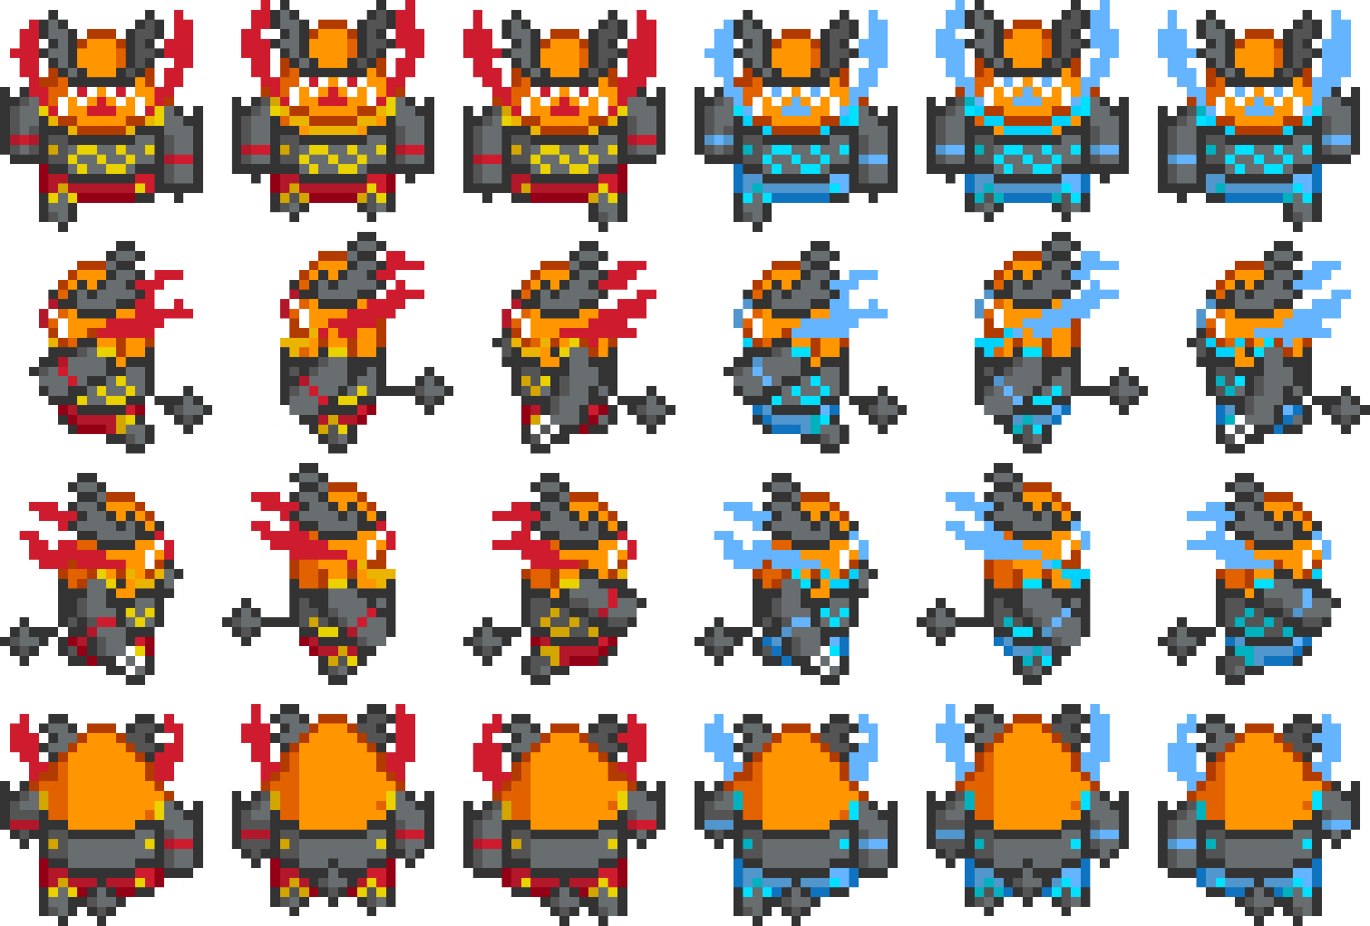

* Reference
* <https://www.google.com/imgres?imgurl=https%3A%2F%2Finreview52838412.files.wordpress.com%2F2021%2F04%2Fenolaholmes-poster.jpg&imgrefurl=http%3A%2F%2Fnapahomerental.com%2From-com-film-posters-landscape-kv.html&tbnid=_QJbzs2IeIESxM&vet=12ahUKEwjb1Ju65ub3AhVCKbcAHeohAX8QMygDegUIARC-AQ..i&docid=CyGcofrM-UiVBM&w=610&h=343&itg=1&q=netflix%20movie%20cover%20landscape&hl=id&ved=2ahUKEwjb1Ju65ub3AhVCKbcAHeohAX8QMygDegUIARC-AQ>
* <https://www.google.com/url?sa=i&url=https%3A%2F%2Felnidobistro.com.ar%2Fbig-landscape-posters-kv.html&psig=AOvVaw2tVr6LIe8ZF59IF0LPNcAa&ust=1652886190485000&source=images&cd=vfe&ved=0CAwQjRxqFwoTCPiuw4Xn5vcCFQAAAAAdAAAAABAU>
* <https://www.google.com/url?sa=i&url=https%3A%2F%2Flamplightreview.com%2Fmovie-review-arrival%2F&psig=AOvVaw2tVr6LIe8ZF59IF0LPNcAa&ust=1652886190485000&source=images&cd=vfe&ved=0CAwQjRxqFwoTCPiuw4Xn5vcCFQAAAAAdAAAAABA1>
* <https://www.google.com/url?sa=i&url=https%3A%2F%2Fgeekteller.com%2Ftag%2Ftv-show%2F&psig=AOvVaw2-Pm721lhn4bOePxa6i8xp&ust=1652887491692000&source=images&cd=vfe&ved=0CAwQjRxqFwoTCNCL8_Dr5vcCFQAAAAAdAAAAABAD>
* <https://www.google.com/url?sa=i&url=https%3A%2F%2Fwww.pinterest.com%2Fpin%2F721701909009869693%2F&psig=AOvVaw3x6EI0N64yHv7aOPPNkn7Y&ust=1652887549127000&source=images&cd=vfe&ved=0CAwQjRxqFwoTCLiimozs5vcCFQAAAAAdAAAAABAw>
* <https://www.google.com/url?sa=i&url=https%3A%2F%2Fwww.techradar247.com%2F2021%2F09%2F04%2Fthe-resident-season-5-emily-vancamp-exits-everything-will-change%2F&psig=AOvVaw1rHSVRnsTWftBGl0z7eXH-&ust=1652888201780000&source=images&cd=vfe&ved=0CAwQjRxqFwoTCMjClsTu5vcCFQAAAAAdAAAAABAD>
* <https://www.google.com/url?sa=i&url=https%3A%2F%2Ftvseriesfinale.com%2Ftv-show%2F9-1-1-season-four-ratings%2F&psig=AOvVaw3jAfxqpSHgj29qOZEzl350&ust=1652888014842000&source=images&cd=vfe&ved=0CAwQjRxqFwoTCJDtjuzt5vcCFQAAAAAdAAAAABAR>
* <https://www.google.com/url?sa=i&url=https%3A%2F%2Fwall.alphacoders.com%2Fby_category.php%3Fid%3D29%26name%3DTV%2BShow%2BWallpapers%26filter%3D4K%2BUltra%2BHD&psig=AOvVaw3x6EI0N64yHv7aOPPNkn7Y&ust=1652887549127000&source=images&cd=vfe&ved=0CAwQjRxqFwoTCLiimozs5vcCFQAAAAAdAAAAABAa>
* <https://www.youtube.com/watch?v=g5VbPXiktGE>
* <https://youtu.be/m8v4nZBcKT8>
* <https://canva.com>
* <https://canva.com>
* <https://www.dafontfree.io/netflix-font/>
* Kelas pertemuan 2, 14 Maret 2022
* Group Member
* 2440026811 – Jessica Angelita
* 2440013576 – Sherleen Beatricia
* 2440007762 – Francesco Jovan
* 2440023242 – Janson Tan